**Spring Security extends ‘Filter’ technology & sits right in front of the web app**

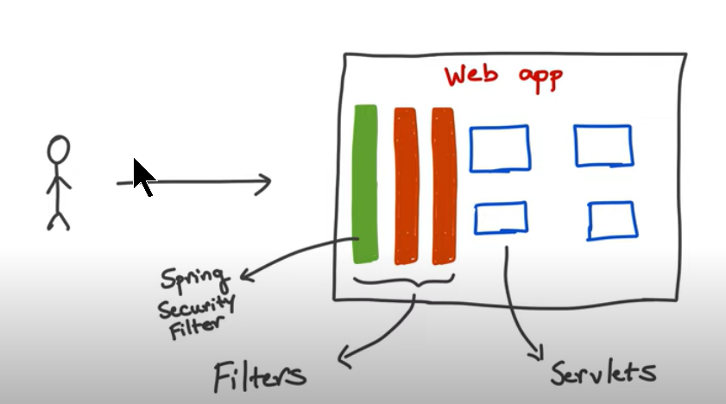

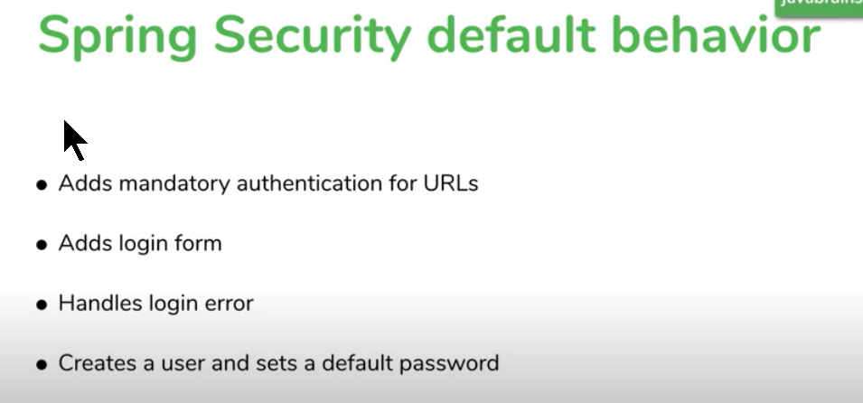

**Tutorial 4**

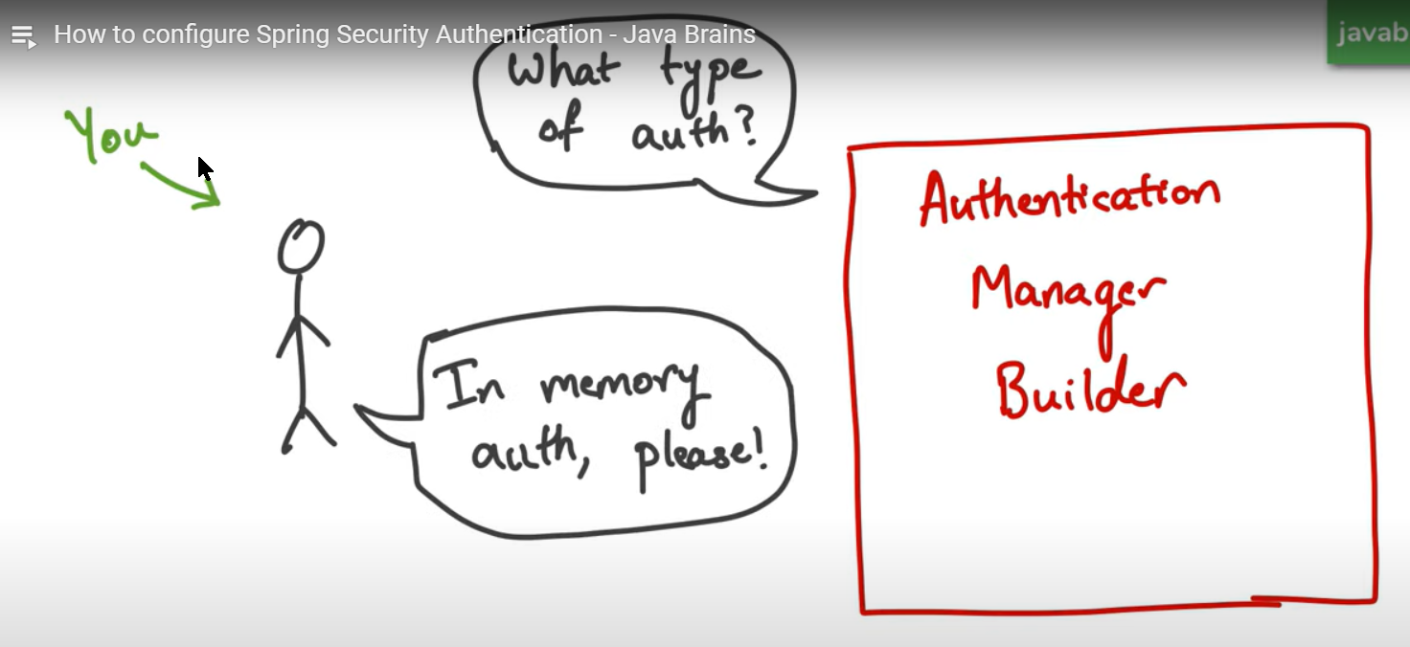

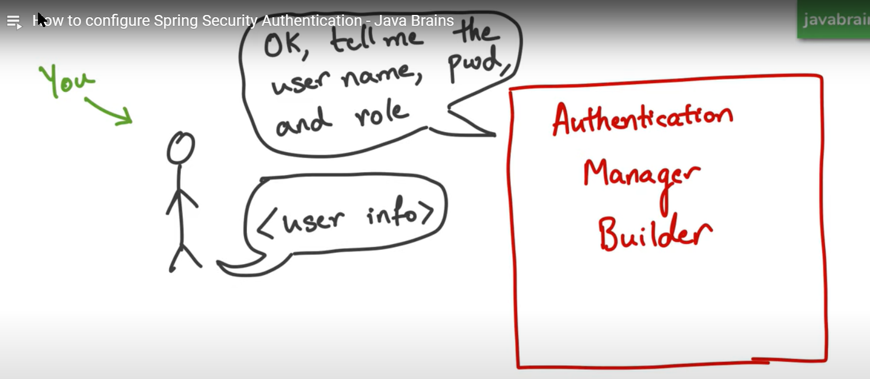

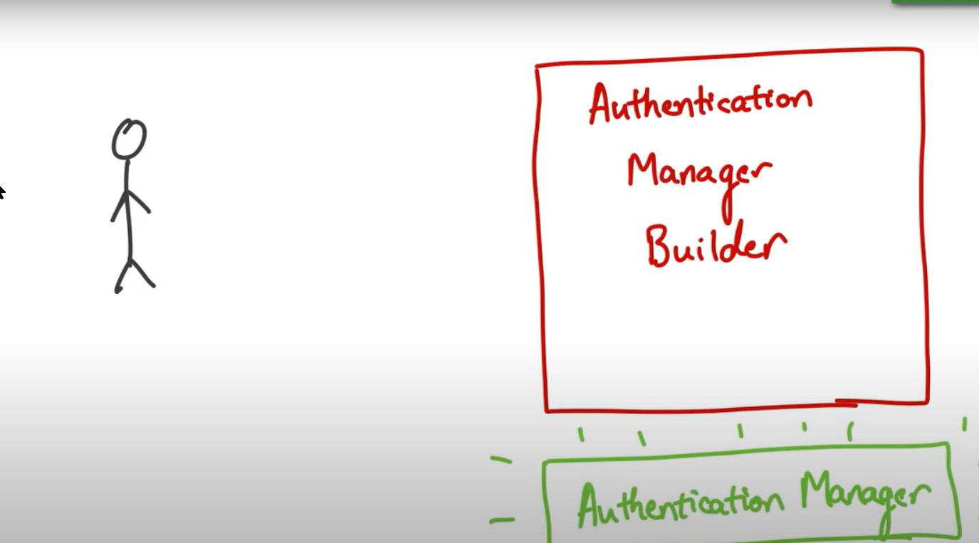

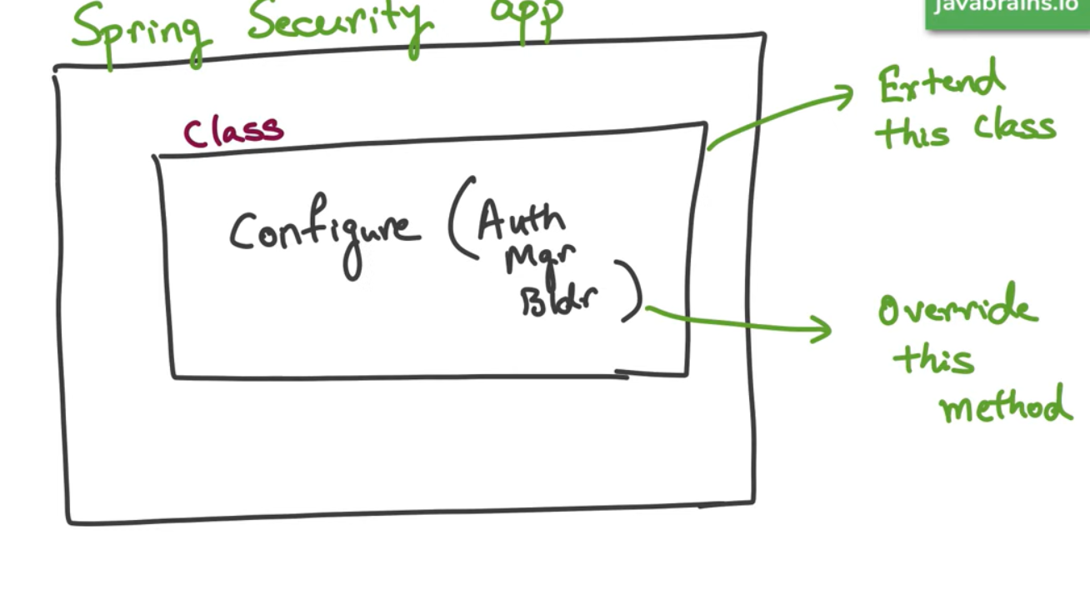

**Tutorial 5**

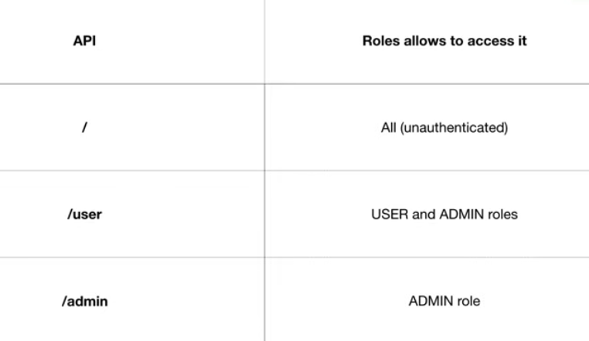

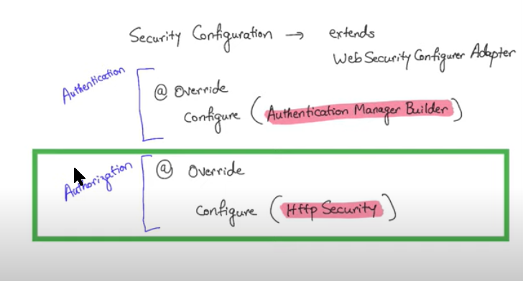

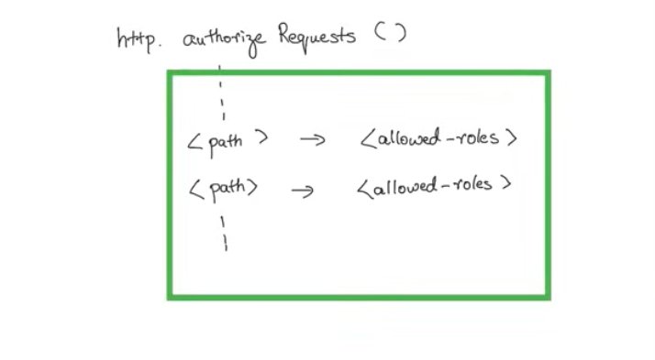

**Tutorial 6**

The Authentication Filter does not return a Boolean after authenticating the user. Instead it returns a Principal object associated with the user

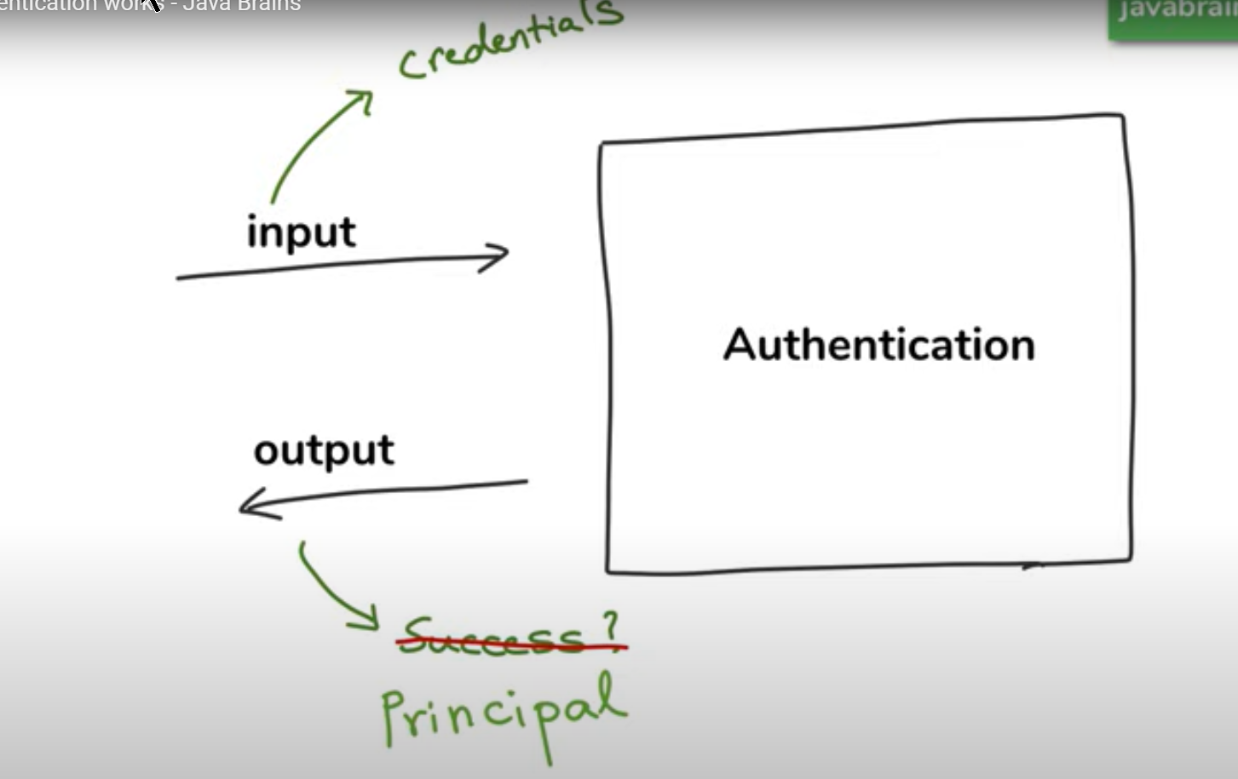

The entered credentials are given to the Authentication Provider via the Authenticate object and if it’s successful, it returns back the Authentication object containing the ‘Principal’ object.

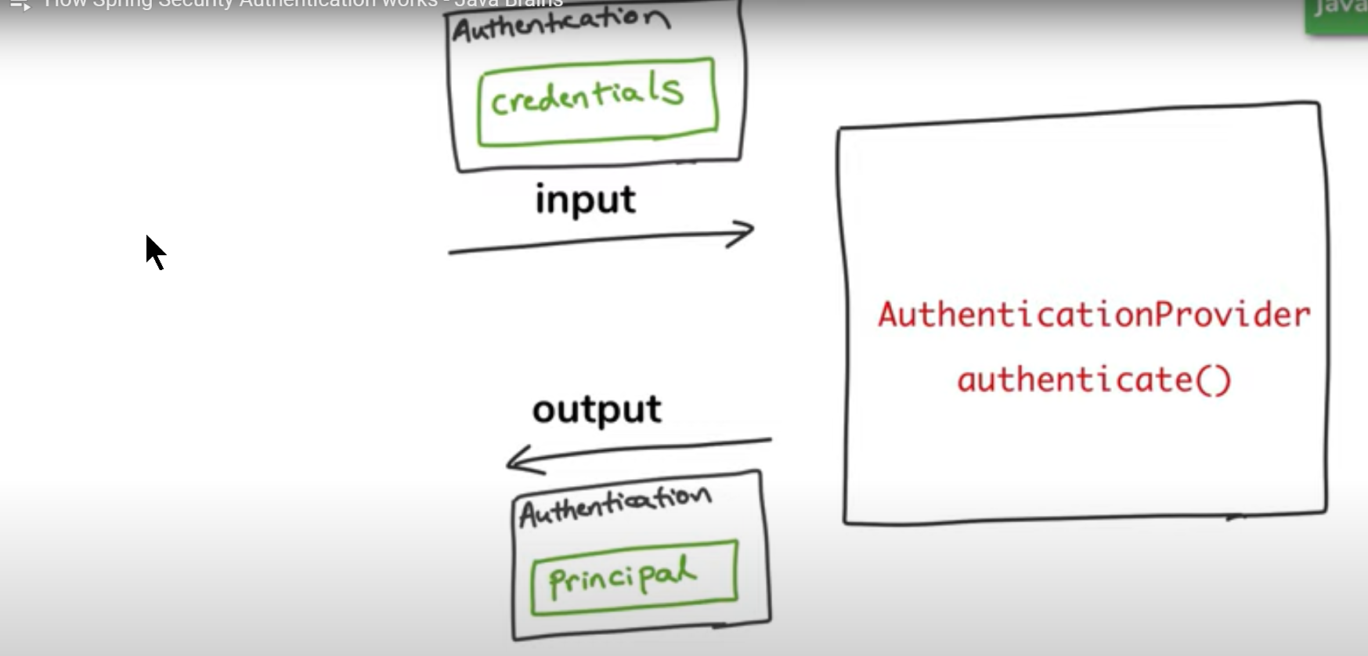

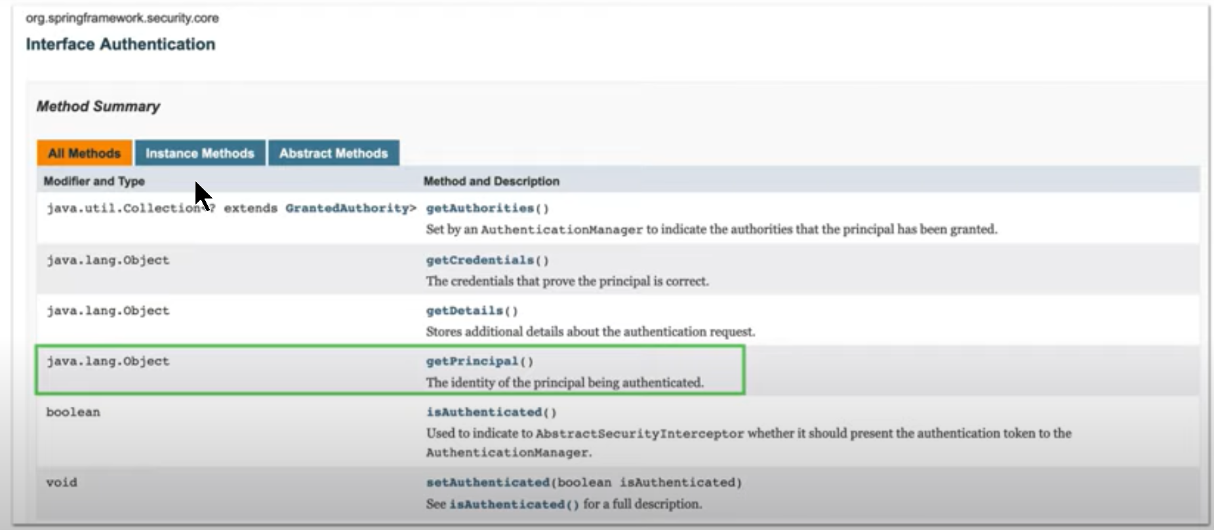

Depending on the strategy of the authentication used in the application, we could have different Authentication Providers

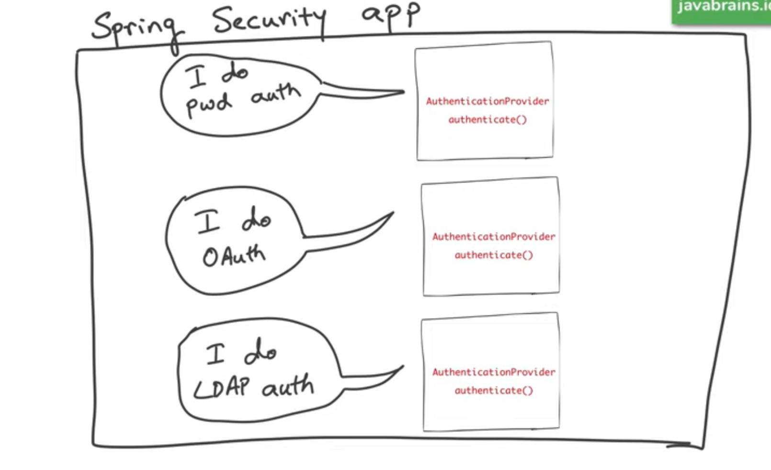

The picture until now

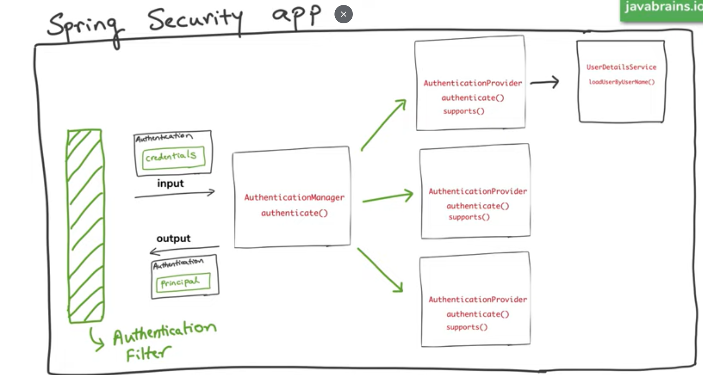

**Tutorial 10** JSON Web Tokens (JWT)

Session based token

* Customer speaks to the support department. The rep makes notes of all the communications and gives the ticket number.
* The next time customer calls, he will use the ticket number as reference

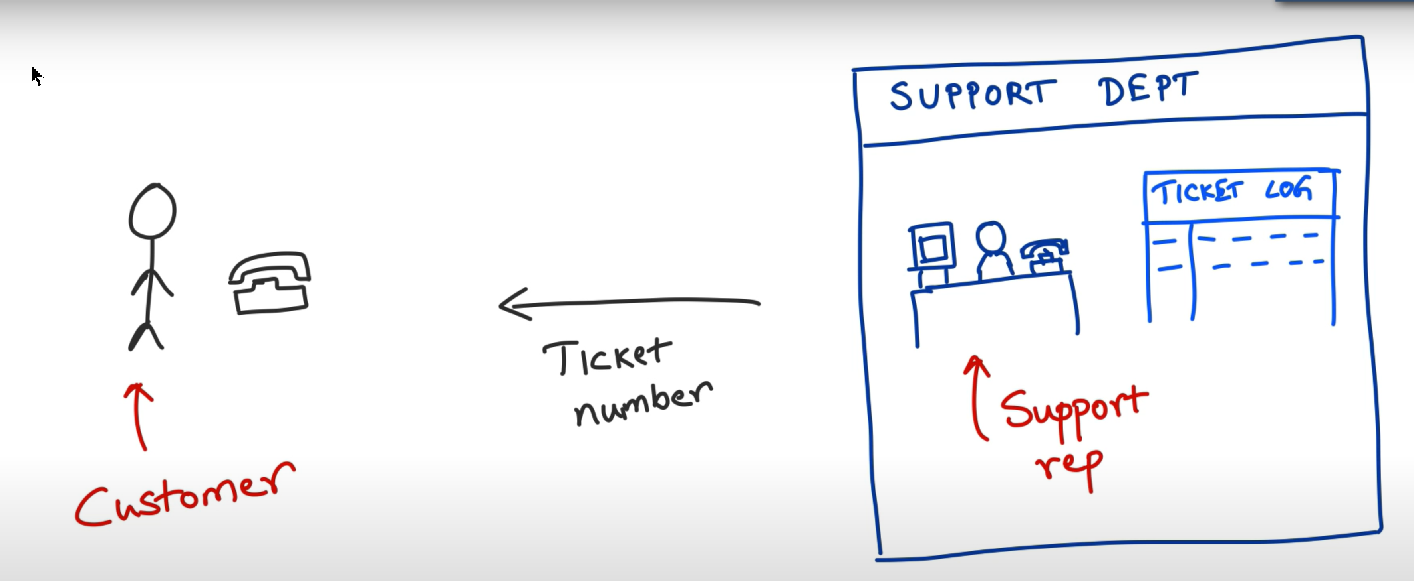

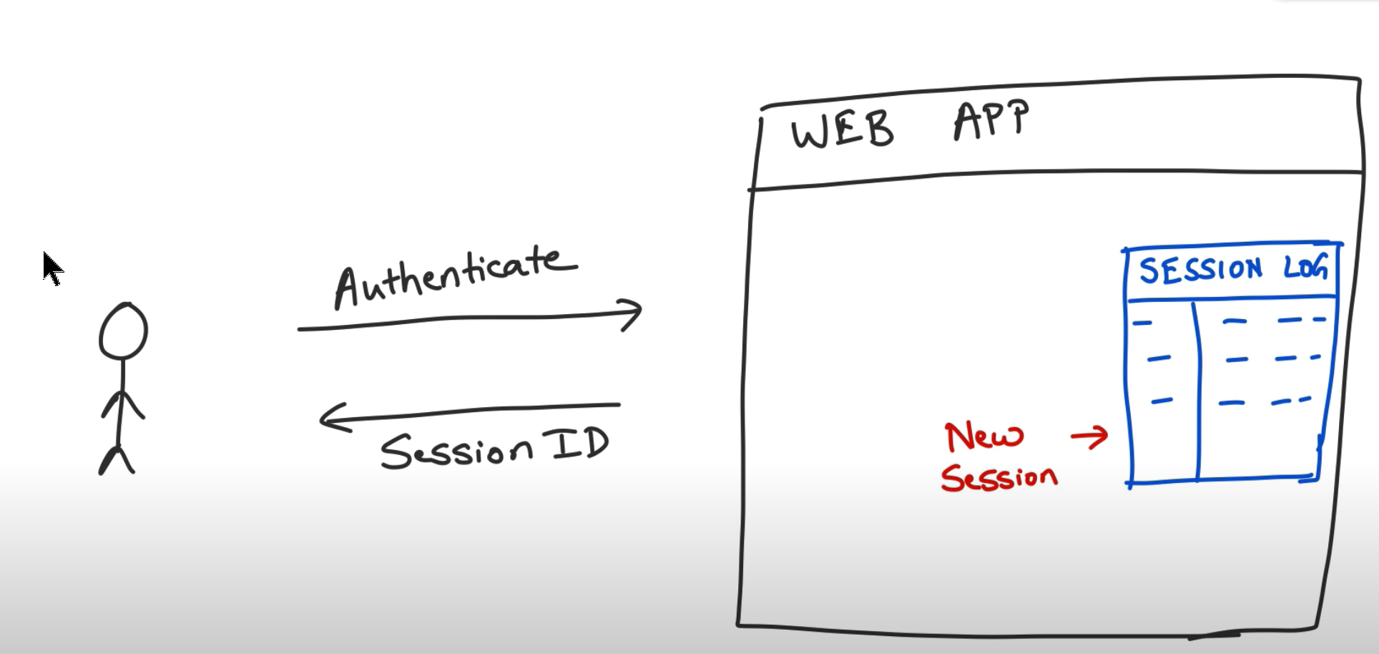

**Sticky Sessions** (request goes to Server1 but the other server does not know about the sessionId returned by the earlier interaction).

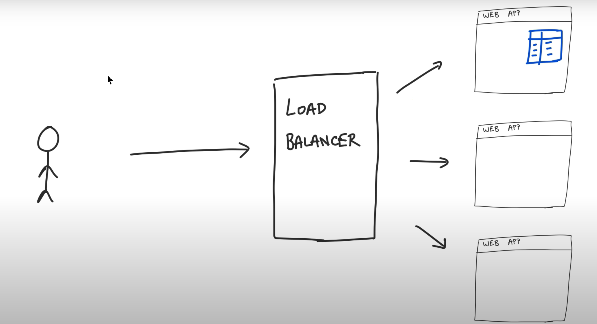

We could have a shared based cache but this becomes as a 1 point failure. If the cache goes down, it will also destroy the session relation information

**Token based authorization**

Instead of giving the ticket, this time the rep gives him the details of the interaction and requests customer to bring this every time he comes. How would the rep trust the next time customer shows this info (customer did not amend the conversation or malicious user did not steal from a genuine customer).

This switch mechanism is where the user information is sent back as a token and also the information is signed so that no tampering can happen with it.

Tutorial 11 – Structure of the JWT token

How JWT token is exchanged between the client and server ?

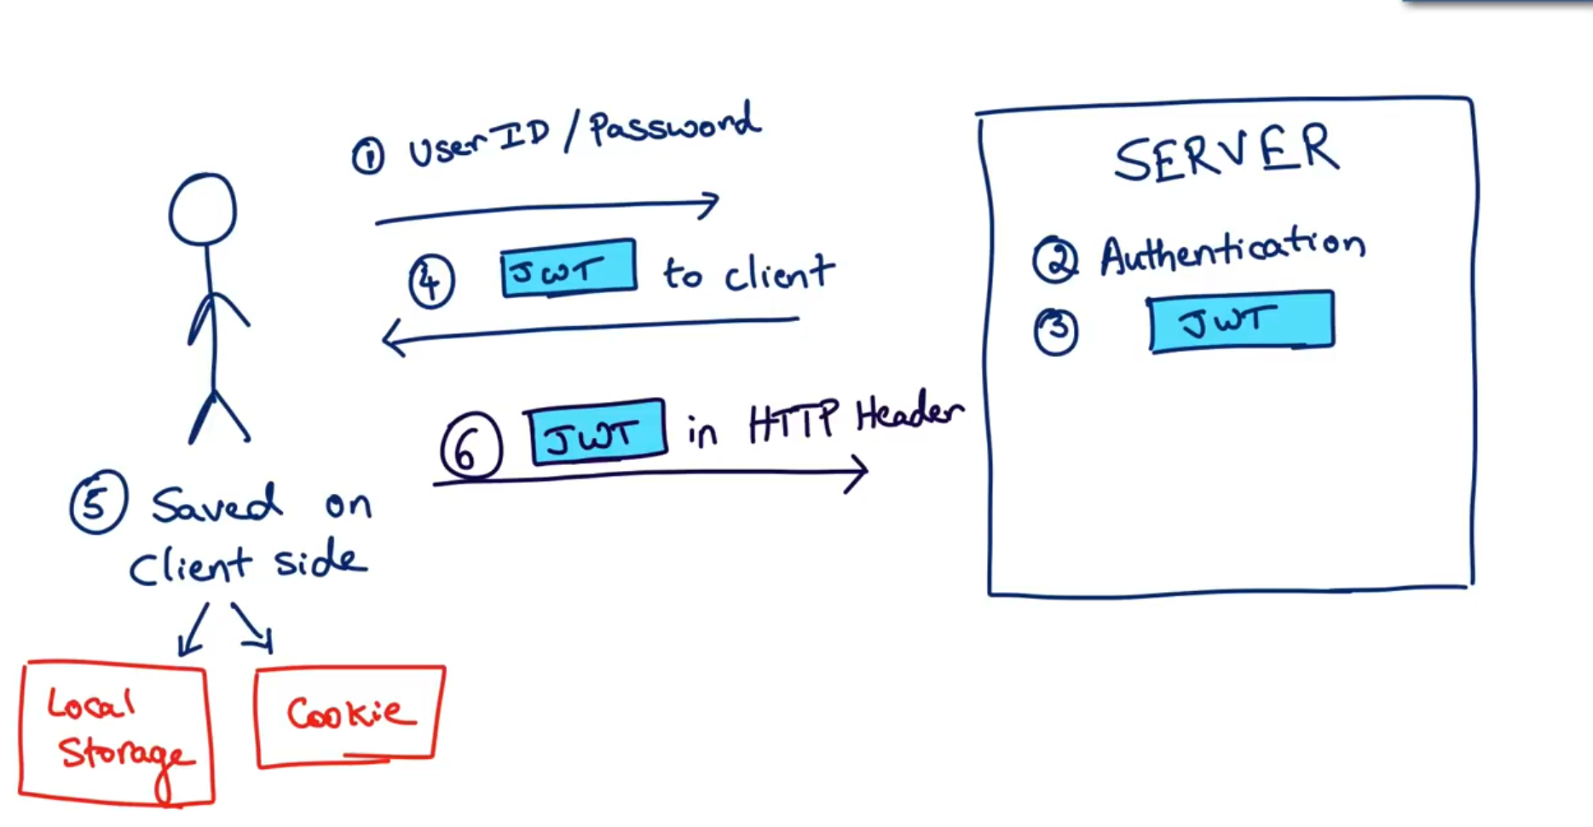

Creating an app which will send the JWT token back to the user on successful authentication

